Lab2 CIS43 Due: 6/22/2016

Name: Nikhil Vytla

***Exercise: Ex 3.11, 3.12, 3.13, and 3.14***

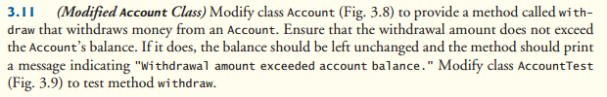

Account

**package** ch3;

**public** **class** Account

{

**private** String name;

**private** **double** balance;

**public** Account(String name, **double** balance)

{

**this**.name = name;

**if** (balance > 0.0)

**this**.balance = balance;

}

**public** **void** deposit(**double** depositAmount)

{

**if** (depositAmount > 0.0)

balance = balance + depositAmount;

}

**public** **void** withdraw(**double** withdrawAmount)

{

**if** (withdrawAmount <= balance)

balance = balance - withdrawAmount; **if** (withdrawAmount > balance)

System.*out*.println("Withdrawal amount exceeded account balance.");

}

**public** **double** getBalance()

{

**return** balance;

}

**public** **void** setName(String name)

{

**this**.name = name;

}

**public** String getName()

{

**return** name;

}

}

-------------------------------------------------

AccountTest

**package** ch3;

**import** java.util.Scanner;

**public** **class** AccountTest

{

**public** **static** **void** main(String[] args)

{

Account account1 = **new** Account("Jane Green", 50.00);

Account account2 = **new** Account("John Blue", -7.53);

System.*out*.printf("%s balance: $%.2f%n",

account1.getName(), account1.getBalance());

System.*out*.printf("%s balance: $%.2f%n%n",

account2.getName(), account2.getBalance());

Scanner input = **new** Scanner(System.*in*);

System.*out*.print("Enter deposit amount for account1: ");

**double** depositAmount = input.nextDouble();

System.*out*.printf("%nadding %.2f to account1 balance%n%n",

depositAmount);

account1.deposit(depositAmount);

System.*out*.print("Enter withdraw amount for account1: ");

**double** withdrawAmount = input.nextDouble();

System.*out*.printf("%nsubtracting %.2f from account1 balance%n%n",

withdrawAmount);

account1.withdraw(withdrawAmount);

System.*out*.printf("%s balance: $%.2f%n",

account1.getName(), account1.getBalance());

System.*out*.printf("%s balance: $%.2f%n%n",

account2.getName(), account2.getBalance());

System.*out*.print("Enter deposit amount for account2: ");

depositAmount = input.nextDouble();

System.*out*.printf("%nadding %.2f to account2 balance%n%n",

depositAmount);

account2.deposit(depositAmount);

System.*out*.print("Enter withdraw amount for account2: ");

withdrawAmount = input.nextDouble();

System.*out*.printf("%nsubtracting %.2f from account2 balance%n%n",

withdrawAmount);

account2.withdraw(withdrawAmount);

System.*out*.printf("%s balance: $%.2f%n",

account1.getName(), account1.getBalance());

System.*out*.printf("%s balance: $%.2f%n%n",

account2.getName(), account2.getBalance());

}

}

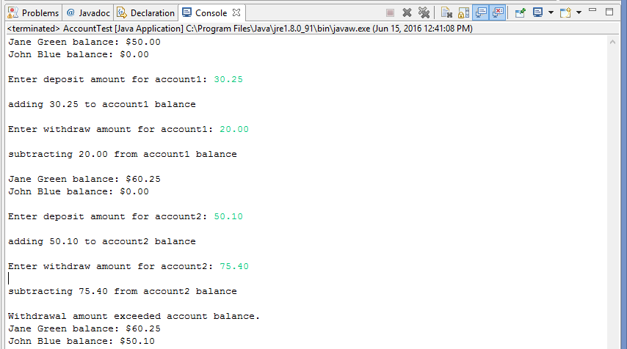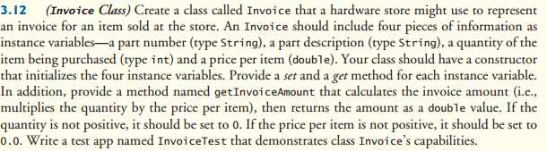

Invoice

**package** P312;

**public** **class** Invoice {

**private** String number;

**private** String description;

**private** **int** quantity;

**private** **double** price;

**public** Invoice(String number, String description, **int** quantity, **double** price)

{

**this**.number = number;

**this**.description = description;

**this**.quantity = quantity;

**this**.price = price;

}

**public** **double** getInvoiceAmount()

{

**double** InvoiceAmount;

InvoiceAmount = quantity * price;

**return** InvoiceAmount;

}

**public** **void** setNumber(String number)

{

**this**.number = number;

}

**public** String getNumber()

{

**return** number;

}

**public** **void** setDescription(String description)

{

**this**.description = description;

}

**public** String getDescription()

{

**return** description;

}

**public** **void** setQuantity(**int** quantity)

{

**this**.quantity = quantity;

}

**public** **int** getQuantity()

{

**return** quantity;

}

**public** **void** setPrice(**double** price)

{

**this**.price = price;

}

**public** **double** getPrice()

{

**return** price;

}

}

-------------------------------------------------

InvoiceTest

**package** P312;

**import** java.util.Scanner;

**public** **class** InvoiceTest {

**public** **static** **void** main(String[] args) {

Scanner input = **new** Scanner(System.*in*);

Invoice invoice1 = **new** Invoice(" ", " ", 0, 0.00);

System.*out*.println("Enter Item Number: ");

String number = input.next();

invoice1.setNumber(number);

System.*out*.println("Enter Description: ");

String description = input.next();

invoice1.setDescription(description);

System.*out*.println("Enter Quantity: ");

**int** quantity = input.nextInt();

invoice1.setQuantity(quantity);

System.*out*.println("Enter Price Per Item: ");

**double** price = input.nextDouble();

invoice1.setPrice(price);

System.*out*.println("Item Number: " + invoice1.getNumber());

System.*out*.println("Item Description: " + invoice1.getDescription());

**if** (quantity > 0)

System.*out*.println("Quantity: " + invoice1.getQuantity());

**else**

System.*out*.println("Quantity: 0");

**if** (price > 0.0)

System.*out*.println("Price Per Item: $" + invoice1.getPrice());

**else**

System.*out*.println("Price Per Item: $0.00");

**if** (quantity > 0 && price > 0.0)

System.*out*.println("Total Invoice Amount: $" + invoice1.getInvoiceAmount());

**else**{

System.*out*.println("Total Invoice Amount: $0.00");

System.out.println(“You have selected incorrect values for either the quantity or the price.”);

}

}

}

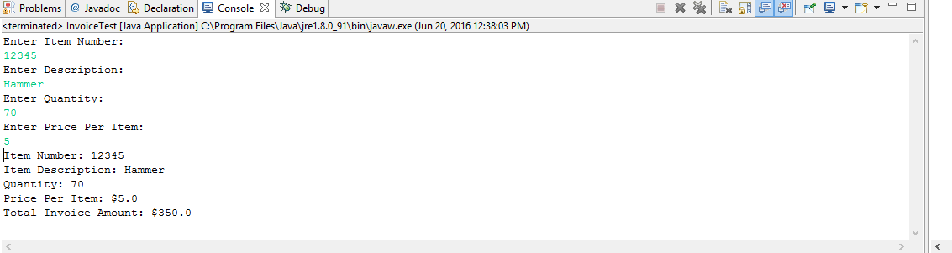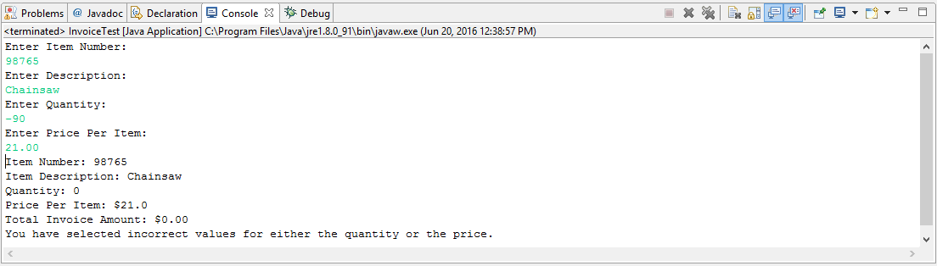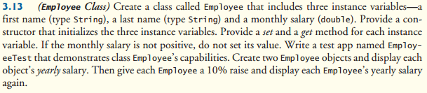

Employee

**package** P313;

**public** **class** Employee {

**private** String firstname;

**private** String lastname;

**private** **double** monthsalary;

**public** Employee(String firstname, String lastname, **double** monthsalary){

**this**.firstname = firstname;

**this**.lastname = lastname;

**if** (monthsalary > 0.00)

**this**.monthsalary = monthsalary;

}

**public** **void** setFirstName(String firstname)

{

**this**.firstname = firstname;

}

**public** String getFirstName()

{

**return** firstname;

}

**public** **void** setLastName(String lastname)

{

**this**.lastname = lastname;

}

**public** String getLastName()

{

**return** lastname;

}

**public** **void** setMonthSalary(**double** monthsalary)

{

**if** (monthsalary > 0.0)

**this**.monthsalary = monthsalary;

**else** **if** (monthsalary < 0.0)

System.*out*.println(" ");

}

**public** **double** getMonthSalary()

{

**return** monthsalary;

}

}

-------------------------------------------------

EmployeeTest

**package** P313;

**import** java.util.Scanner;

**public** **class** EmployeeTest {

**public** **static** **void** main(String[] args) {

Employee employee1 = **new** Employee("Bob", "Elefante", 5000.00);

Employee employee2 = **new** Employee("Maria", "Farallon", -2456.53);

System.*out*.printf("%s %s's yearly salary: $%.2f%n",

employee1.getFirstName(), employee1.getLastName(), employee1.getMonthSalary()*12);

System.*out*.printf("%s %s's yearly salary: $%.2f%n%n",

employee2.getFirstName(), employee2.getLastName(), employee2.getMonthSalary()*12);

System.*out*.println("Here's a 10% raise!");

System.*out*.printf("%n%s %s's new yearly salary: $%.2f%n",

employee1.getFirstName(), employee1.getLastName(), employee1.getMonthSalary()*12*1.1);

System.*out*.printf("%s %s's new yearly salary: $%.2f%n%n",

employee2.getFirstName(), employee2.getLastName(), employee2.getMonthSalary()*12*1.1);

}

}

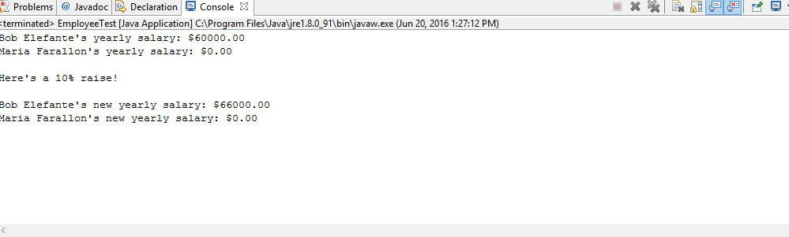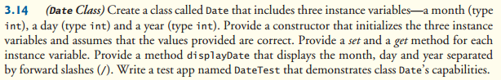

Date

**package** P314;

**public** **class** Date {

**private** **int** month;

**private** **int** day;

**private** **int** year;

**public** Date(**int** month, **int** day, **int** year){

**this**.month = month;

**this**.day = day;

**this**.year = year;

}

**public** **void** setMonth(**int** month)

{

**this**.month = month;

}

**public** **int** getMonth()

{

**return** month;

}

**public** **void** setDay(**int** day)

{

**this**.day = day;

}

**public** **int** getDay()

{

**return** day;

}

**public** **void** setYear(**int** year)

{

**this**.year = year;

}

**public** **int** getYear()

{

**return** year;

}

**public** String displayDate()

{

**return** month + "/" + day + "/" + year;

}

}

-------------------------------------------------

DateTest

**package** P314;

**public** **class** DateTest {

**public** **static** **void** main(String[] args) {

Date date1 = **new** Date(4, 20, 2012);

System.*out*.printf("Today's date is %s.", date1.displayDate());

}

}

